Detailing how each requirement was met, design decisions, programming tricks, and helpful resources consulted is required to be submitted as a hard copy on demo day.

The project process started up with gathering the requirement to design a functional database, setting up the primary keys and foreign keys and creating appropriate tables to store relevant data that will be used throughout the creating of the site.

Forms were created to accept user input and appropriate conditional statement and security measures were taken to ensure the backend will not be easily compromised.

Connection were made with msqli functions together with built in function’s were used. we organized the use of Array. Functions, stored the session Id’s for references across the entire .php files.Below is the schematic representation of the database being queried using SQL

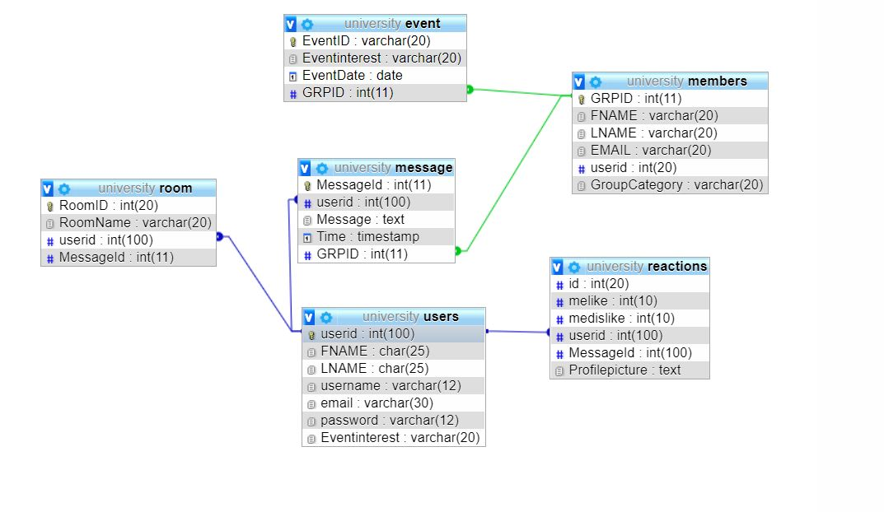

Resources used w3schools, PHP website, stack overflow, Youtube